Nama : Sidna Muhammad Zen

NIM : 18090144

Kelas : 5B

**PRAKTIKUM 1**

1. Source Code

Kenalan.php -> application/controller

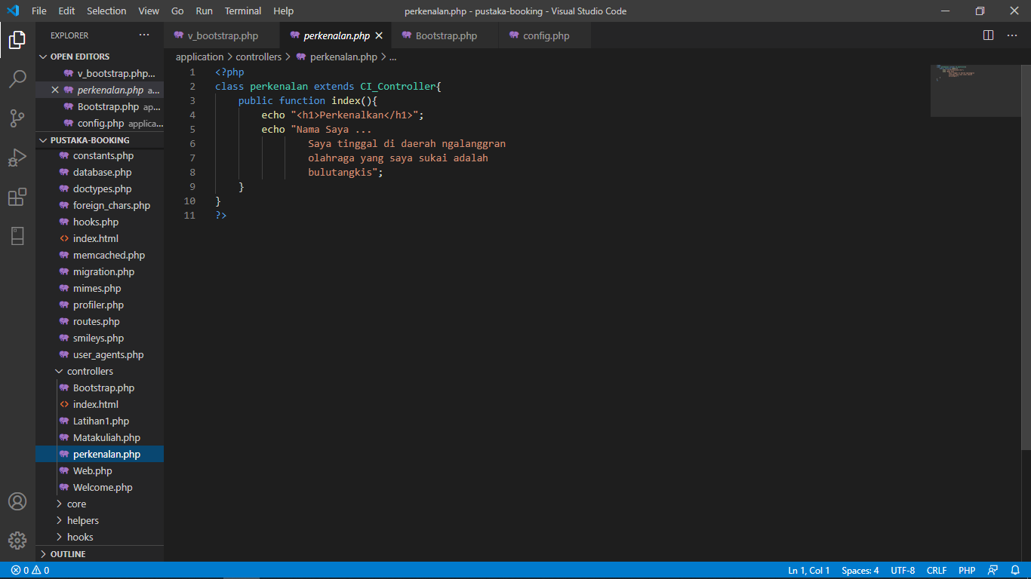

1. URL

[http://localhost/pustaka_haniff/index.php/](http://localhost/pustaka_haniff/index.php/kenalin)perkenalan

1. Capture Hasil

